1. Cat, a Parrot, and a Bag of Seed:

A man finds himself on a riverbank with a cat, a parrot and a bag of seed. He needs to transport all three to the other side of the river in his boat. However, the boat has room for only the man himself and one other item (either the cat, parrot, or seed). In his absence, the cat could eat the parrot, and parrot would eat the bag of seed. Show how he can get all the passengers to the other side, without leaving the wrong ones alone together.

1. **Define the Problem** – A man needs to get across the river in a small boat. Not enough room in the boat for himself, the cat, the bird, and the birdseed. He only has enough room for himself and one other item. He needs to make sure that the cat isn’t left alone with the parrot or the parrot isn’t left alone with the birdseed. The problem is whether these are the only two scenarios that can be dangerous. The overall goal is to get all of them with the birdseed to the other side of the river, but other problems can be part of this. The Boat needs to be safe, the water needs to be as calm as possible, the weather needs to be nice, and the birdseed needs to be kept dry. The overall goal is for all of them to get safely across with the birdseed.
2. **Break the problem apart** – The boat is too small for everything to fit and some of these animals/item cannot be left together alone. The cat cannot be left alone with the parrot because he may hurt it. The parrot cannot be left alone with birdseed because he may eat it. The sub-goals would be to keep everything safe and make it to the other side with the dry birdseed dry.
3. **Potential Solutions** – The man needs to be sure the water is as still as possible and weather is good. Make sure the birdseed is wrapped tightly to protect from water, or placed in an airtight container. He should also make sure the boat is watertight before using it. If all of these problems are fixed, the man needs to set up plan to get his goal accomplished. He can take the cat over first, the birdseed second, the dog third, and take the bird last. He will have to travel back and forth 7 times.
4. **Evaluate each potential solution -** Each solution does meet all of the goals. Each solution may not work for all cases such as: There is the possibility of the boat tipping over and the birdseed getting wet or one of them getting hurt. There is also the possibility of bad weather, which can prevent him from making it across to the other side.

**5) Choose a solution and develop a plan to implement it.**

Make sure the weather is fair, the boat is watertight, and the bag of birdseed is also watertight. The man should take the birdseed across the river first. Second trip would include the dog. Third trip would include the cat and the final trip would have the parrot. Since the parrot is the last to go, he can’t be involved with the birdseed or the cat.

See example below:

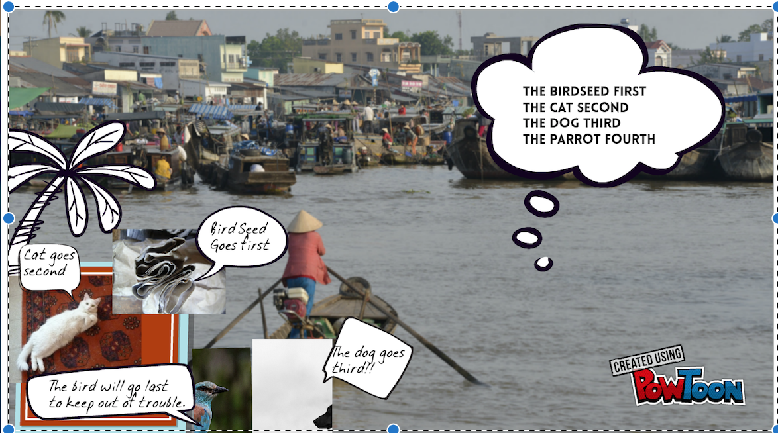

1. Socks in the Dark:

There are 20 socks in a drawer: 5 pairs of black socks, 3 pairs of brown and 2 pairs of white. You select the socks in the dark and can check them only after a selection has been made. What is the smallest number of socks you need to select to guarantee getting the following:

1. At least one matching pair.
2. **Define the problem** – There are 30 pairs of socks in a drawer and you must be able to pick out a match without seeing them until selections are made. Chances of pulling a black pair are 50%, chances for a brown pair are 30%, and chances of pulling a white pair are 20%. It is most likely you will pull a black pair.

The overall goal is to pull a match with the least amount of attempts. Knowing this number will keep you from pulling more socks than required to make a match.

1. **Break the problem apart –** Themain constraints are the lack of being able to view the socks in the drawer and the fact they are laying singly in the drawer. Determine the least amount of socks to pull that guarantee a match. Sub-goals can include size and style of the socks.
2. **Identify potential solution –** A possible solution to the sub-goals would be to feel and measure the socks while pulling them out of the drawer to ensure they are the same type. The best solution is to pull the least amount needed with 3 colors of socks. She could take out all of the socks to find the match or since there are three colors, she could take out 4 which will ensure a match with the least number of socks pulled.
3. **Evaluate each potential solution.**

Each solution does not meet the goal of pulling the least amount to guarantee a match. This means that all methods do not work for all cases, but each solution reaches the goal of matching a pair of socks.

1. **Choose a solution and develop a plan to implement it.**

The best solution is take 4 socks (since there are three colors) and match the fourth sock to it’s match. When you have a drawer full of three different color socks, you are bound to have a match with just 4 socks.

SAMPLE:

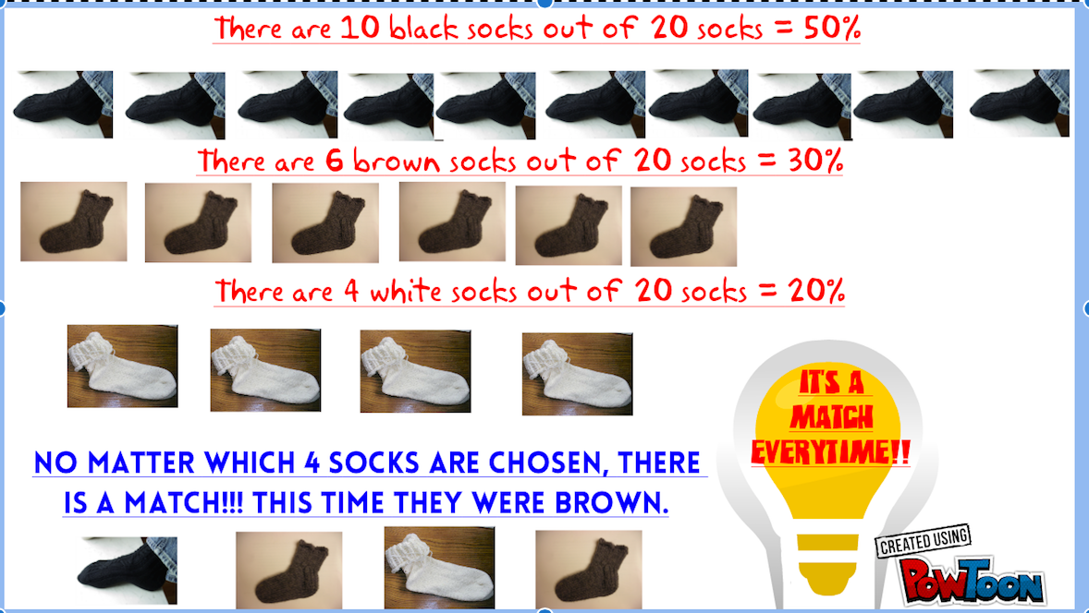

1. At least one matching pair of each color.
2. **Define the problem** – There are 30 pairs of socks in a drawer and you must be able to pick out two matches without seeing them until selections are made. Chances of pulling two black pairs are still 50%, two brown pairs are still 30%, and two white pairs are still 20%. The most likely pairs would be from the black or the brown pairs. The overall goal is to obtain two matches with the least amount of attempts.
3. **Break the problem apart –** Themain constraints are the lack of being able to view the socks in the drawer and the fact they are laying singly in the drawer. Determine the least amount of socks to pull that guarantee two matches. Sub-goals can include size and style of the socks.
4. **Identify potential solution –** A possible solution to the sub-goals would be to feel and measure the socks while pulling them out of the drawer to ensure they are the same type. The best solution is to pull the least amount needed with 3 colors of socks and make two matches.
5. **Evaluate each potential solution.**

Each solution does not meet the goal of pulling the least amount to guarantee a match. This means that all methods do not work for all cases, but each solution reaches the goal of matching a pair of socks as long as there isn’t the constraint of how many you pull. By pulling 6 socks, you will meet the goal.

1. **Choose a solution and develop a plan to implement it.**

The best solution is take 6 socks (since there are three colors) and match at least 2 socks to its match. There is also the possibility of matching 3 socks with its match. When you have a drawer full of three different color socks, you are bound to have at least 2 matches with just 6 random socks.

Sample;

SEE NEXT PAGE

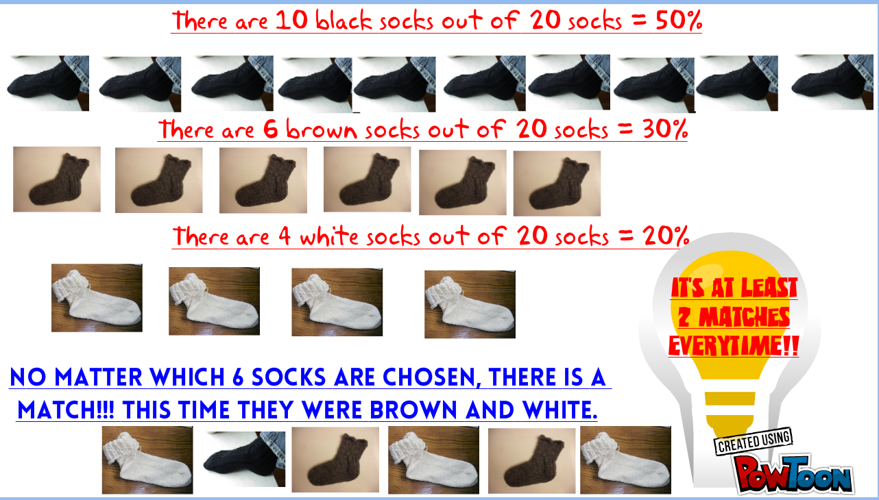

1. Predicting Fingers:

A little girl counts the fingers of her left hand as follows: She starts by calling her thumb 1, the first finger 2, middle finger 3, ring finger 4, and little finger 5. Then she reverses direction, calling the ring finger 6, middle finger 7, first finger 8 and thumb 9, after which she calls her first finger 10 and so on. If she continues to count in this manner, on which finger will she stop?

1. What if the girl counts from 1 to 10?
2. What if the girl counts from 1 to 10?
3. What if the girl counts from 1 to 1000?